
1.3. Biological information

1.3.1. Recording areas
Recording areas are shown in Maps 12b, d, e & f

1.3.2. Data sources and under-recorded groups

Specific data sources are listed below.

Group | Data source(s)
Vascular Plants | Orchid survey, D. Bell (2010)  Survey of meadow species (2008 & 2011)  NVC Survey, Tickner & Evans (1990)
Fungi | Dean Fungus Group (1993)  Marriot/ British Mycological Society (1977, 1981, 1989, 1990, 1991)
Moths | Gaunt (2003)  Jackson (2006)
Butterflies | N. Williams (2009)  Annual Butterfly transect, Site staff (1977-)  Small pearl-bordered fritillary survey, D. Bell & H. Williams (2010 & 2011)
Newts | D. Dewsbury (2010)
Lichens | Carle et al. (2006)
Hoverflies | Iliff (2006)
Orthoptera | Wake (1992, 2002)
Other invertebrates | Gibbs (2004)  Cave (1994)  Alexander (1982)
Fish | NRA (1992)
Birds | Annual Point Counts  Selected key breeding species recorded annually
Bats | Palmer, E, Bonfield, C, Downs, N & Philips, B. (2007)

Under-recorded groups

Group(s) | Habitat | Current level of recording | Comments
Mammals | Throughout reserve | Ad-hoc | Dormouse  Badger  Wild boar
Mammals, bats | Throughout reserve | Single survey Aug 2007 | Whiskered, Common pipistrelle, Barbastelle, Noctule, Brown long eared bat & Lesser horseshoe all recorded at least once
Dead-wood fauna | Deadwood | Historic
Vascular plants | Various | 14 locally uncommon species not surveyed since 1990
Bryophytes | Throughout | None
Fungi | Throughout | Little recorded since 2006
Non-native invasive | Throughout | Ad-hoc | None recorded through annual reporting system
Moths | Throughout | Ad-hoc

1.3.3. Habitats

The distribution of habitats on the reserve is shown in Map 13. The areas of NCC Phase 1 habitats are given in the following table.

NCC Phase 1 habitats on the reserve

Habitat |  | Code | Status | Area (ha) | Comments
Woodland | Old oak plantations (pre 1850) | A.1.1.2.1 | SSSI feature 130.8 ha | 180 | 99.5 ha enclosed  80.5 ha grazed
Woodland | Young oak plantations (1947/1971/2001) | A.1.1.2.1 |  | 19
Woodland | Conifer plantations | A.1.2.2.1 |  | 33
Woodland | Mixed plantations | A.1.3.2.1 |  | 24
Scrub | Planted scrub (dense acidic) | A.2.1.1 |  | 9
Scrub | Scattered acidic scrub | A.2.2.1 |  | 10.5
Open grassland | Mainly recently felled woodland | A.4 |  | 24
 | Semi-improved grassland | B.2.2.2 |  | 4
Total |  |  |  | 303.5

1.3.4. Vegetation communities

Areas of NVC communities on the reserve are shown in the table below.

NVC community | Status | Area (ha) | Comments
W10 Quercus robur-Pteridium aquifolium-Rubus fruticosus agg. Woodland |  | 234.7 | Includes W16 Woodland
W7 Alnus glutinosa-Fraxinus excelsior-Lysimachia nemorum woodland |  | 8
W25a Pteridium aquilinum-Rubus fruticosus agg. Underscrub, Hyacinthoides non-scripta sub community |  | 3.8
U4b Festuca ovina-Agrostis capillaries-Galium saxatile grassland, Holcus lanatus-Trifolium repens sub-community |  | 0.4
CG7 Festuca ovina-Hieracium pilosella-Thymus praecox grassland |  | 0.6
MG1 Arrenatherum grassland |  | 3.2 | Holcus lanatus-Vicia spp.grassland in 1990
MG10a Holcus lanatus-Juncus effuses rush-pasture |  | 0.6
Total |  | 251.3 | Remaining areas are conifer or mixed broadleaves/conifer plantation

1.3.5. Important plant and animal species
Plants
Species | Popn. size | Status | Comments
Ivy-leaved Bellflower  Wahlenbergia hederacea | Unknown | Not been seen since 2004 | Further surveying required
(Fern-leaf) Dropwort  Filipendula vulgaris | Unknown | Not been seen since 2006 | Further surveying required
Common Spotted Orchid  Dactylorhiza fuchsii | Unknown | 660 spikes recorded on the meadows in 2008 | Monitoring required, <100 spikes in 2011
Heath Spotted Orchid  Dactylorhiza maculata  (possible) | Unknown | Seen 2006, mentioned in SSSI citation | Monitoring and identification confirmation required
Broad-leaved Helleborine  Epipactis helleborine | Unknown | Seen 2009, mentioned in SSSI citation | Further surveying required
Common Twayblade  Neottia ovata | Unknown | Present 2006 | Monitoring required

Breeding birds
Species | Popn. Size |  | Status | Comments
Deciduous woodland
Eurasian Woodcock  Scolopax rusticola | 4 males in 2008 |  | Amber list
Stock Dove  Columba oenas | 8 pairs in 2006 |  | Amber list
Green Woodpecker  Picus viridis | Max 7 pairs |  | Amber list | Last confirmed in 2008
Lesser Spotted Woodpecker  Dendrocopos minor | 2* drumming males |  | Red list,  BAP priority | Notable reserve species
Dunnock  Prunella modularis | Unknown |  | Amber list, BAP priority | Woodland edge species, also breeds in clear-fell re-growth
Common Redstart  Phoenicurus phoenicurus | 7 singing males in 2011 |  | Amber list | Notable reserve species
Song Thrush  Turdus philomelos | Unknown |  | Red list,  BAP priority | Full CBC in 2003 gave 103 pairs, min 96 calling males in 2008
Mistle Thrush  Turdus viscivorus | 17 males in 2008 |  | Amber list
Wood Warbler  Phylloscopus sibilatrix | 10 singing males in 2011 |  | Red list,  BAP priority | Notable reserve species, also breeds in mixed woodland
Spotted Flycatcher  Muscicapa striata | 10 pairs in 2011 |  | Red list,  BAP priority | Possibly under recorded in previous years, also breeds in mixed woodland
Pied Flycatcher  Ficedula hypoleuca | 38 nesting attempts in 2011 |  | Amber list | Notable reserve species, UK declines
Marsh Tit  Poecile palustris | 8 males 2008 |  | Red list,  BAP priority | Eight singing males in 2008
Eurasian Bullfinch  Pyrrhula pyrrhula | Unknown |  | Amber list, BAP priority | Nine pairs in 2007, four pairs in 2008, woodland edge species
Hawfinch  Coccothraustes coccothraustes | Unknown |  | Red list,  BAP priority | Singing males recorded annually.  Regular sightings in 2011 breeding season, notable reserve species, Forest of Dean of national importance
Coniferous woodland
Northern Goshawk  Accipiter gentilis | Unknown |  | Green list  Schedule 1 | Probable breeder, pair heard in spring 2011 in suitable habitat. Last confirmed record 2006
Firecrest  Regulus ignicapillus | Unknown |  | Amber list  Schedule 1 | Probable breeder, at least one singing male in 2011, rare UK breeder, also in mixed woodland.  Last confirmed record 2006
Eurasian Siskin  Carduelis spinus | Unknown |  | Green list,  Local interest | Pair recorded 2008, Scarce Gloucestershire breeder
Common Crossbill  Loxia curvirostra | Unknown |  | Green list,  Schedule 1  Local interest | Possible breeder, Scarce Gloucestershire breeder
Clearings and scrub
Common Cuckoo  Cuculus canorus | 1-2 males in 2011 |  | Red list,  BAP priority | Possible breeder, also on woodland edges
European Nightjar  Caprimulgus europaeus | 3 churring males in 2011 |  | FDIV,  Red list,  BAP priority | Limited by availability of open habitat, more come onto reserve from adjacent clear-felled areas
Tree Pipit  Anthus trivialis | 6* singing males |  | Red list,  BAP priority | Reserve numbers limited by availability of open habitat
Common Whitethroat  Sylvia communis | 2 singing males in 2011 |  | Amber list | Reserve numbers limited by availability of scrub habitat
Willow Warbler  Phylloscopus trochilus | 15* singing males |  | Amber list | Possibly under recorded, also breeds on woodland edge
Quarry
Peregrine Falcon  Falco peregrinus | 1 pair in 2011 |  | Green list  Schedule 1 | Notable reserve species
Raven  Corvus corax | 1 pair in 2011 |  | Green list | Notable reserve species
Water bodies
Mandarin Duck  Aix galericulata | 1-2 pairs | N/A |  | Notable reserve species, in deciduous woodland
Mallard  Anas platyrhynchos | 1 pair in 2011 | Amber list
Common Kingfisher  Alcedo atthis | Unknown | Amber list |  | Possible breeder along Cannop Brook
Grey Wagtail  Motacilla cinerea | 1 pair | Amber list |  | Last confirmed 2008, along Cannop Brook
Dipper  Cinclus cinclus | 1 pair | Green list |  | Notable reserve species, last confirmed 2008, along Cannop Brook
* Mean 2005-2011

Non-breeding birds
Species | Popn. Size | Status | Comments
Eurasian Woodcock  Scolopax rusticola | N/A | Amber list | Commonly seen through the winter
Lesser Redpoll  Carduelis cabaret | N/A | Red list,  BAP priority | Large numbers seen through the winter feeding on birch and alder
Hawfinch  Coccothraustes coccothraustes | N/A | Red list,  BAP priority | Small flocks commonly seen through the winter
Redwing  Turdus iliacus | N/A | Red list | Flocks commonly seen through winter

Other Fauna
Species | Popn. Size | Status | Comments

Mammals
Wild Boar  Sus scrofa | Unknown | Unprotected, Numbers controlled by FCE | First appeared 2006. The extent of the ecological impact if this species is still unknown.
Deer | Unknown | Unprotected, Numbers controlled by FCE | Fallow are predominant species, Roe also present. Occasional reports of Red within forest area, and more recent sightings of Muntjac
Bats – Barbastelle, Noctule, Brown Long-eared, Daubenton, Pipistrelle & Lesser Horseshoe | Unknown | European Protected Species | Individuals known to roost within visitor centre roof & behind signage, as well as around Campbell Hide. Other roosts likely to be present, but not identified

Reptiles
Adder  Vipera berus | Unknown | BAP priority | Further surveying required
Amphibians
Great Crested Newt  Triturus cristatus | Unknown | European protected species,  BAP priority | Further surveying required

Invertebrates
Small Pearl-bordered Fritillary  Boloria selene | Fluctuates year to year | BAP priority | Further surveying required, bumper season in 2011 with 19 individuals recorded on a single visit, this was reflected in other populations in the area
White Admiral  Limenitis camilla | Unknown | BAP priority | Recorded in 2009 and 2010, food plant: Honeysuckle Lonicera periclymenum
Dingy Skipper  Erynnis tages | Unknown | BAP priority | Recorded in 2009 and 2010
Drab Looper  Minoa murinata | Unknown | BAP priority,  Nb | Further surveying required, laval food plant is Wood Spurge Euphorbia amygdaloides

1.3.6. Population trends of important plant and animal species
Breeding population trends shown below are for all data available. Species have not necessarily been surveyed in detail across the whole reserve annually, although the point count survey does cover the whole reserve. The data represented here, with the exception of pied flycatcher, is taken from territory mapping carried out targeting key species. The following abbreviations are used: CBC: Common Bird Census; BBS: Breeding Bird Survey. Both are standard methodologies used by volunteers to provide information to the British Trust for Ornithology (BTO) on breeding birds in the UK.
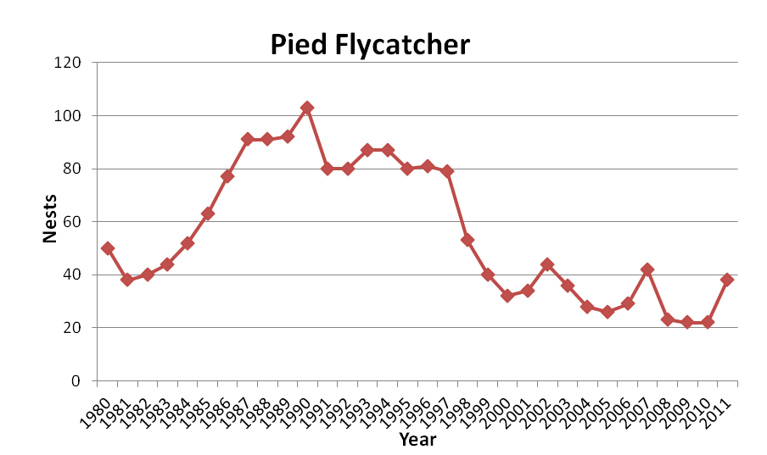

Pied flycatcher data is recorded through the nestbox monitoring scheme, and therefore represents the number of nesting attempts in nestboxes. 2011 data includes seven singing males in Russell’s Inclosure which, if successful in finding a mate, will have nested in natural holes. No such records exist for nesting attempts outside of nestboxes is included for other years

The declines in breeding attempts by pied flycatchers on the reserve is greater than the pattern seen nationally: results from CBC and BBS surveys show national declines of 54% since the mid nineties (Baillie et al, 2010). Reasons for declines are uncertain, evidence from the Netherlands suggest that climate change may have made peak food availability earlier, but pied flycatchers have been unable to respond with earlier nesting dates (Both et al, 2006). Anecdotal evidence (I. Proctor & F. Lander, pers comm) does not support this at Nagshead, there is more concern that food availability is low throughout the year, although no data is available to substantiate this and the reasons for declines in caterpillar abundance is unknown. There is evidence to suggest that the reasons behind pied flycatcher declines may be partly associated with migration and wintering grounds (Goodenough et al, 2009).

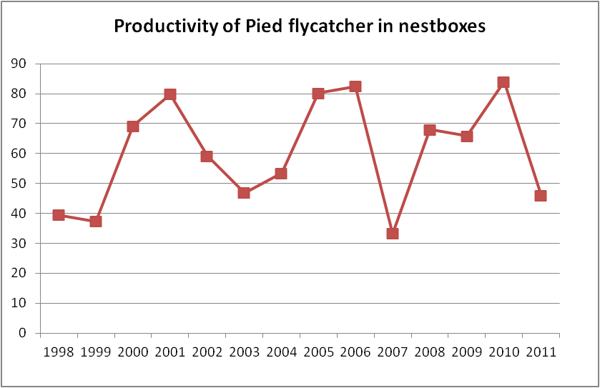

Productivity of pied flycathcers, as seen above, is variable. In 2011 low productivity was noted to be linked to heavy rainfall on two successive weekends in the breeding season when may of the pied flycatcher broods were almost ready to fledge. Whole broods of almost fully grown chicks were found dead in nestboxes after these weekends.
It has also been noted that productivity has an effect on number of breeding attempts the following year.
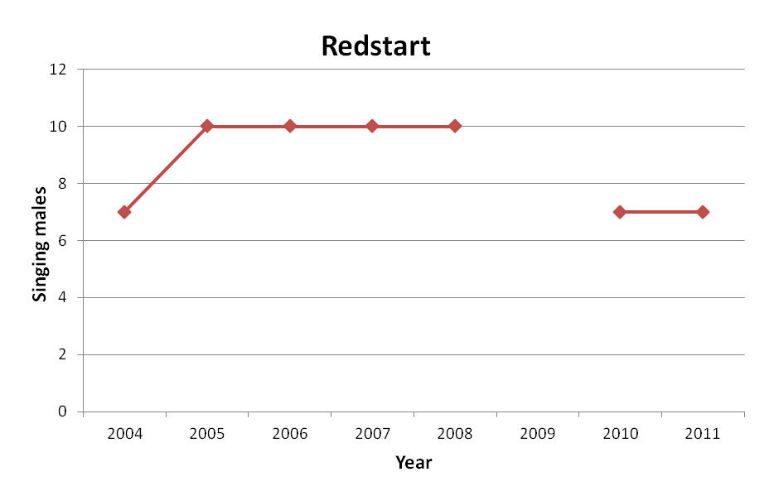
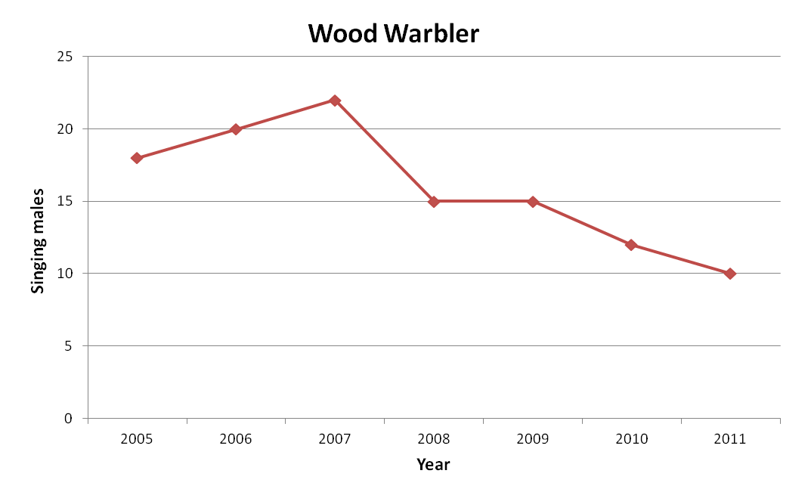

Breeding Bird Survey (BBS) data shows national declines of 14% in this species in the 10 years from 1998 -2008 , and a 2% decline between 2003-2008 (Baillie et al, 2010). Reserve records show an increase over that 5 year period, but a subsequent decline. It should be noted that at one time redstarts used the nestboxes in the western part of the reserve, but have declined significantly in that area and now do not use the boxes at all. In recent years they have been restricted to the SSSI area of woodland at Russell’s Inclosure.

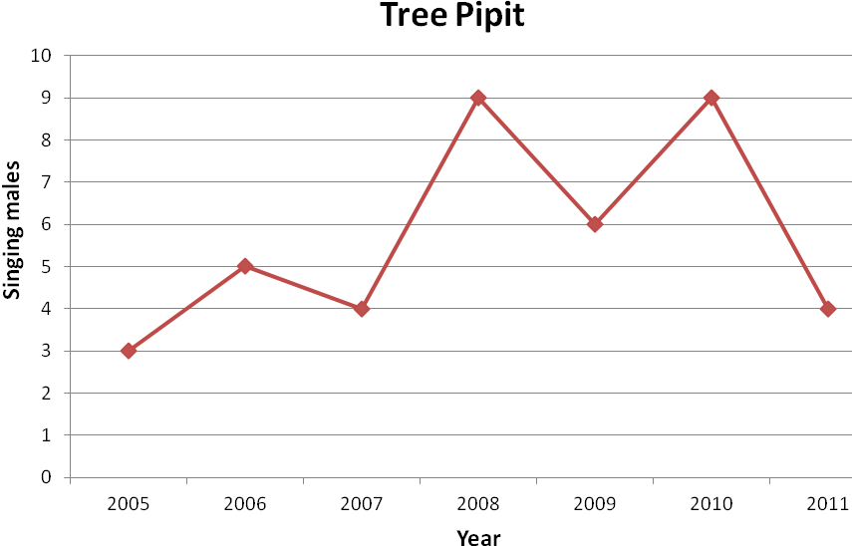
Wood warblers appear to be retreating from lowland England, which is most likely linked to the rapid and significant declines nationally since 1994 (Baillie et al, 2010). Reserve data shows more than 50% decline in this species since 2007.

Although there is fluctuation in the annual number of pairs breeding on the reserve, the general trend for tree pipits is an increase, contrary to the national trend of 24% decline (03-08) (Baillie et al., 2010). Within the life of the last two reserve management plans there has been a significant increase in areas of suitable habitat for this species on the reserve. A significant area of this (in compartment 16) is plantation and will hence be lost as breeding habitat in the near future, although the heath is expected to continue to provide habitat for 1-2 pairs.

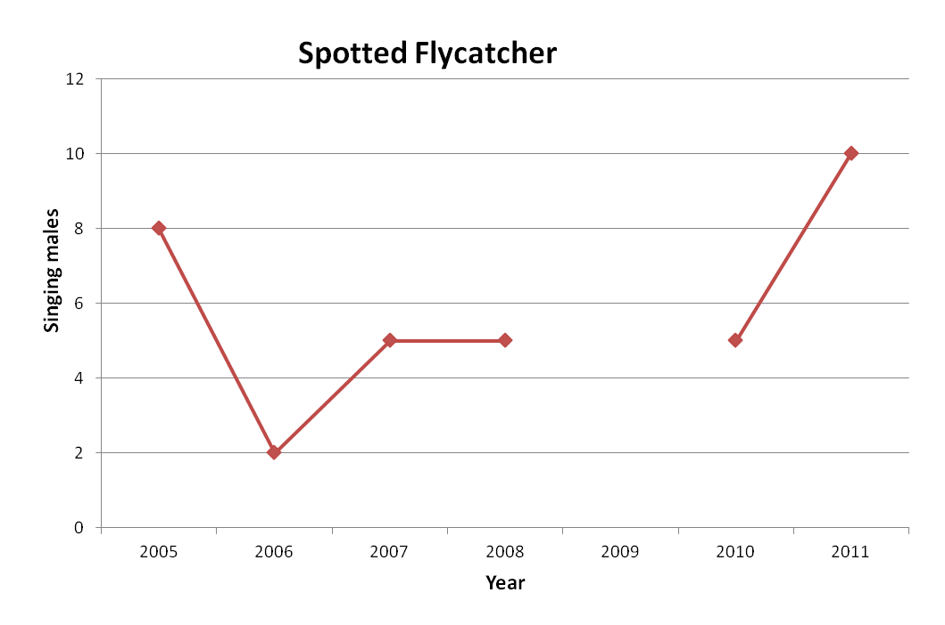

The sharp increase in number of pairs of spotted flycatcher recorded in 2011 compared to 2010 is most likely due to increased recording effort for this species in 2011. It is noted though that the overall increasing trend for this species reflects the pattern for the south west region, contrary to the nationally recorded decline of 11% (03-08) (Baillie et al, 2010).
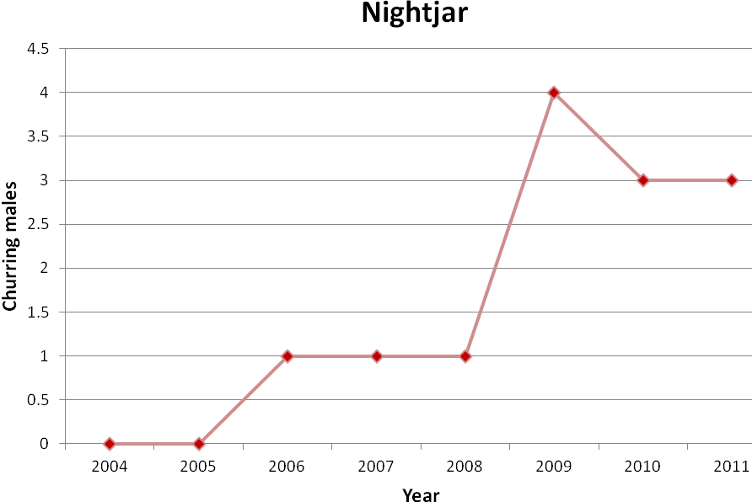

Nightjar, like tree pipit, is closely associated with clearfell areas within the forest. This species will not remain as a breeding species on the reserve. They will be at risk in the wider forest if management moves away from clearfell to continuous cover.

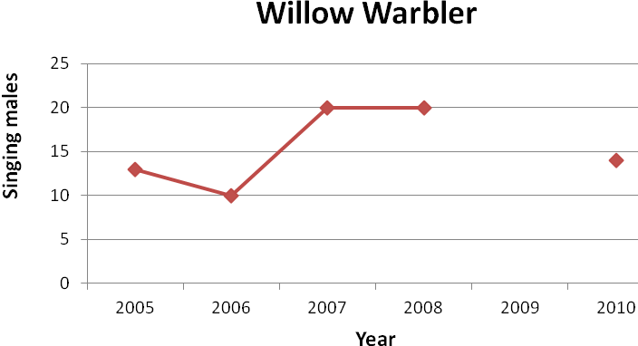

Although nationally willow warblers have increased over the 5 years from 2003-08, this masks the pattern which suggests they are shifting their range to the north. Significant increases in Scotland and Northern Ireland are compensating for declines in the south. It seems on the reserve there was an increase over the same 5 year period, when they would have been expected to decline, but with more recent declines visible by 2010 it may be that this is merely a delay.

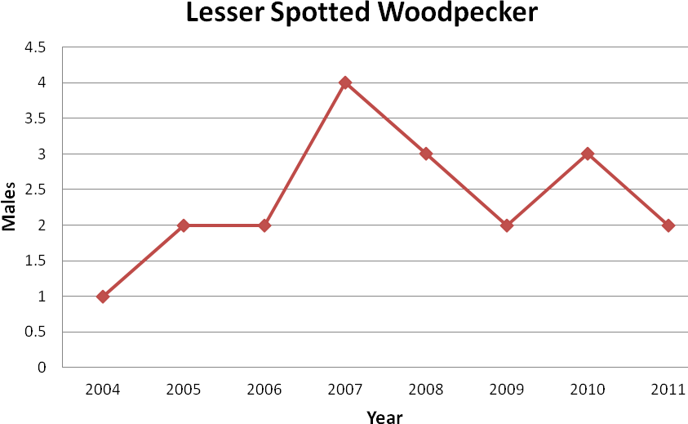

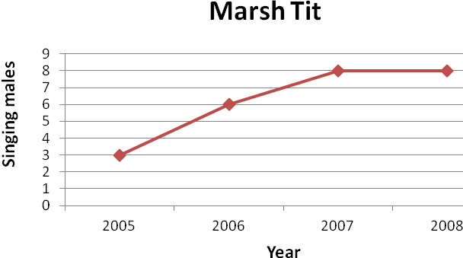
Again it would seem that the population of lesser spotted woodpecker was increasing, or at least relatively stable, on the reserve at a time when there were national declines (33% 2003-08) (Baillie et al, 2010). The location of the reserve protects this species from pressures such as habitat fragmentation and landscape scale loss of broadleaf woodland that are seen elsewhere. Potentially the species is still exposed to competition with greater spotted woodpeckers and may face a reduction in smaller diameter deadwood on which they rely for foraging.

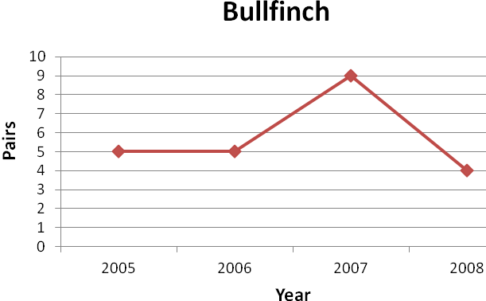
BBS data shows marsh tit to have declined nationally between 2003-08 (Baillie et al, 2010). This data clearly shows the opposite trend on the reserve over the same time period. This may be at least partly due to the location of the reserve within the wider forest, as it is known that the steeper declines are recorded in smaller, isolated areas of woodland.

c. What are the wildlife spectacles through the year? SEASONALITY CHART, RSPB NAGSHEAD – WHAT TO SEE AND WHEN
 | January | February | March | April | May | June | July | August | September | October | November | December
Churring Nightjars
Pied Flycatchers
Other summer migrants
Bird song
Common Spotted Orchids
Meadow flowers
Glow Worms
Autumn colours
Fungi
Winter migrants
Hawfinches
Bluebells
Passage migrants
Dragonflies
Small Pearl-bordered Fritillaries
Silver-washed Fritillaries
Other butterflies
Ancient woodland
Reptiles
Spawning frogs and toads
Fallow Deer
Fallow Deer rut
Fallow Deer fawns
Wild Boar
Wild Boar piglets
Breeding bird surveys

2. EVALUATION and RATIONALE FOR MANAGEMENT

2a. Conservation

2a.1. Current issues and constraints
- Grey squirrels are present in the woods. This species is known to strip bark which will affect growth in susceptible species, including pedunculate and sessile oaks, cherry and birch as well as non-native sycamore and sweet chestnut. Ash and alder do not appear to be affected on the reserve. FCE no longer carry out control
- Deer. Fallow are the principle species on the reserve, but roe, muntjac and red have all been recorded within the forest. There is some evidence of browsing affecting regeneration within the reserve area, however, there is currently no understanding of how this may be balanced by the reduction in sheep grazing over the last 10 years. FCE carry out deer monitoring and cull for population control purposes within the forest, including on reserve.
- Wild Boar first appeared within the forest, probably as a result of a deliberate release, in 2006. Numbers have significantly increased and they are now accepted to be a permanent feature of the ecosystem, although they are a difficult species to monitor and there is some uncertainty as to current population size. There is also little understanding of the ecological impact this species will have within the reserve. Some of the animals demonstrate little fear towards humans, and are frequently seen throughout the day along roads and paths in the forest, including on the reserve. This could potentially be a threat to visitors, especially dog walkers, when there are young at foot. This site would benefit from a national RSPB policy for this species.
- Livestock grazing has declined in the forest significantly over the last 10 years since foot and mouth disease struck. This has led to a less defined differentiation in habitat between the grazed and ungrazed areas of the reserve, and will have consequences on breeding bird populations. Until recently it was believed that it was not possible to fence stock into areas of the forest, therefore making management of open areas more difficult. Thanks to recent work by FCE it seems it may be possible to fence and enclose stock into small defined areas. This would enable RSPB to work more closely with Commoner’s Association and regain some control of grazing in areas of the reserve, such as traditionally grazed woodland areas along with areas to be maintained as open habitat.
- Lease with FCE. The nature of the agreement with FCE means there is joint management responsibility between the two organisations. FCE management planning being delivered through the Forest Design Plan which currently runs out of sync with this management plan. Some aspects of the FDP will result in changing habitats, with some species loss, within the reserve area, but this will be countered with habitat creation within the wider forest area.
Tenants covenants – not to fell or prune trees without consent of Landlord. All timber is reserved to the Landlord who manage the woodland for silvicultural purposes in accordance with the Management Plan (timber not to be removed during bird nesting & breeding season)
- Conflict of use. There is low level conflict between users, particularly birdwatchers and dog walkers. Signs asking all dog owners to keep dogs on leads are present during the breeding season are not always effective, and there have also been some complaints about the presence of dogs through the winter. There is a proposed horse riding trail which will run close to the reserve. The exact route and potential impact is not yet known. FCE (landlord) reserve rights to hold motor rallies (mid-Nov to mid-Feb) and horse riding events on reserve with reasonable notice to us as tenant. In practice these rights have not effected the reserve to date

2a.2. Identification of the Features Influencing Management of the site

The following tables list all the important features identified in Section 1.2-1.4 and identifies which of these are the Features Influencing Management.

These include:

** = Features which are the prime reason for RSPB maintaining the reserve and which will drive its management.

✓✓ = Features for which we have legal responsibilities (SSSI interest features) and which will influence the management we undertake at the site.

✓= Features for which we have legal responsibilities (SSSI interest features) but which will not influence the management we undertake at the site.

* = other important conservation features whose requirements we need to take into account when deciding upon management of the site.

V = Features of particular importance to visitors.
- Woodland
Important feature | Influencing Management? | Why?
Woodland (part SSSI) – Old oak plantation woodland W10 | ✓✓** | SSSI Interest feature over part of the reserve. One of three sites within the Forest of Dean (FoD) that is of nature conservation importance
Woodland (SSSI) – Alder carr woodland W7 | ✓ | SSSI Interest feature
Woodland – Oak-birch-wavy hair grass W16 | *
Breeding lesser spotted woodpecker | ** | Red listed, BAP priority species. Dependent on retention of deadwood and is included in SSSI bird assemblage
Breeding song thrush | * | Red listed
Breeding redstart | ✓✓*V | Amber listed, characteristic of western oakwood and SSSI bird assemblage which depends on open woodland structure
Breeding wood warbler | *V | Red listed, BAP priority species characteristic of western oakwood bird assemblage
Breeding spotted flycatcher | * | Red listed, Bap Priority species
Breeding pied flycatcher | **V | Amber listed, characteristic species of western oakwood bird assemblage. UK declines
Breeding marsh tit | ✓✓ | Red listed, SSSI bird assemblage
Breeding hawfinch | * | Red listed
Breeding northern goshawk | * | Schedule 1
Breeding firecrest | * | Schedule 1
Breeding bird assemblage | ✓✓V | SSSI feature. Woodland species are declining nationally
Bats | ✓ | European Protected Species, legal requirement not to disturb roosts
Badgers | ✓ | European Protected Species, legal requirement not to disturb
Ivy leaved Bellflower  Wahlenbergia hederacea | * | Only recorded site in county
Ground flora | V | Extensive areas of Hyacinthoides non-scriptus and other vernal & pre-vernal ground flora communities which respond to management
Saproxylic invertebrates | * | Potentially important assemblage of at least county significance (as part of Cannop Valley); wider FoD of national importance
Other woodland invertebrates | *V | Some red listed
- Open habitats
Important feature | Influencing Management? | Why?
Neutral semi-improved grassland MG1 | *V | Isolated and herb rich mesotrophic community that is scarce in the wider FoD, especially which is pro-actively managed for conservation
Bracken-Bramble underscrub W25 | * | Early successional scrub habitat with adjacent woodland that is important for many red & amber listed bird species.
Acid grassland U4 and rush pasture MG10 | * | Increasingly scarce and local within FoD, supports many open habitat species
Exposed vertical rock face / quarry area | * | Breeding raven and peregrine falcon
Open water | * | Regionally important assemblage of Odonata
Breeding nightjar | *V | Red listed, FDIV, BAP priority species, but is it expected that can they be kept within larger FoD area.
Breeding tree pipit | ** | Red listed, BAP priority species, characteristic of western oakwood bird assemblage
Small pearl bordered fritillary | * | FoD is the last stronghold for this species in Gloucestershire, Barracks

2a.3. Condition of the Features Influencing Management and the Main Factors affecting them
The following tables identify the target condition of the Features Influencing Management and the Main Factors influencing whether these target conditions are attained.

- Woodland
Feature | Attribute(s) | Current | Target(s) for attribute | Main factor(s) | Target for main factor(s) | Comments
Woodland (SSSI) – Old oak plantation woodland W10  Native broadleaved woodland (non-SSSI) | Extent | SSSI = 130.8 ha  (80.5 ha grazed and 53ha ungrazed)  Non-SSSI = 94ha | Maintain current area with ancient semi-natural character
 | Age structure | SSSI -Predominantly over 150 years,  Non-SSSI varied structure | Range from veteran trees to young regeneration | Uniform plantation character of plantation woodland and limited natural regeneration  Deer browse  Squirrel Damage | Controlled regeneration under old oak canopy. Two main regimes create areas 1) open structure, grazed and 2)diverse structure ungrazed  Clearfell areas restricted to no more than 30% replanted  Maintain deer impact assessment monitoring and population control  Deer fence areas identified for regeneration | Current reduced grazing levels, since 2001, are resulting in less differences between the 2 areas  FC no longer control grey squirrels in Forest of Dean
 | Species composition | Mostly high forest with stands dominated by oaks, birch and some beech.  Holly | 95% of all layers to be native broadleaves only. Beech not to exceed 10% of mature canopy area.  Maintain current extent | Locally, non-native species and beech are becoming dominant | Remove non-native trees and beech to attain target | Extent taken from Structure survey
 | Structure and natural processes | Open grazed areas- -uniform 19th century plantings  Ungrazed areas - uniform 19th century plantings with regeneration | Maintain open structure (high forest wood pasture) with sufficient grazing to maintain a grazed herb layer throughout 90% of area; only 10% total area to be 2-5m understorey with 2% of this regenerating  Regeneration be visibly present favouring site native species | Inadequate number of sheep grazing in the grazed areas, allowing ubiquitous recent regeneration  Structure frequently maintained by non-native species, including at canopy level | Increase grazing to a level that maintains open character. Monitor structure with a view to investigating future management options.  Encourage regeneration by native species only through active selection of non-native species during thinning operations | Effects of grazing by common and wild herbivores needs to be considered when attempting to manipulate grazing pressure in selected areas
 | Structure and natural processes - dead wood | Not estimated | Minimum of 3 fallen lying trees >20cm diameter per ha and 4 trees per ha to die standing | Deadwood not allowed to develop and remain | No removal of deadwood except for safety reasons.  Leave broadleaf trees on site to achieve this attribute target.  NB Historic thinning management old oak has reduced the creation of standing deadwood in grazed areas.  Create deadwood baseline data.
 | Structure and natural processes – rides and glades | Extent – randomly distributed through reserve, especially glades artificially created on a grid in cpt 6 | Maintain current areas | Existing glades in cpt 6 to be allowed through natural birch stage. | Glade creation in SSSI to be through natural processes.
(SSSI) Woodland – Alder carr woodland W7 | Extent | 8 ha | Maintain current areas
 | Age structure | Range of age classes | Retain range of age classes (ca. 10% of trees coppiced on 5 year cycle) | Cessation of coppicing | Continue coppicing in 3 areas by Cannop Brook
Conifer and mixed broadleaves/  conifer | Extent | 57ha (33ha pure conifer | Reduce areas of pure conifer | No removal of conifer due to permanent conifer retention blocks
Conifer and mixed broadleaves/  conifer | Species composition | Non-native broadleaves and conifers present, sometimes locally exceeding 90% canopy | 95% native broadleaves (as SSSI). Retain Scots pine through reserve | Spread of non-native trees through seeding-in within broadleaved areas | Prioritise removing free-seeding non-native trees.  Remove seedling conifers to facilitate site-native broadleaf regeneration. | Some retention of coniferous species advantageous for goshawk / coal tit / crossbill / firecrest / goldcrest
Conifer and mixed broadleaves/  conifer | Structure and natural processes - dead wood | Not estimated | Minimum of 3 fallen lying trees >20cm diameter per ha and 4 trees per ha to die standing | Deadwood allowed to develop and remain | No removal of deadwood except for safety reasons.
Breeding bird assemblage | LS territorial males | 5-year average of 2 | 5-year average of >2 | Deadwood habitat for breeding and feeding. | Conifer removal. Retention of deadwood
Breeding bird assemblage | ST singing males | Unknown | 5-year average of >73 | All wooded habitats | Retain current woodland management regime
Breeding bird assemblage | RS singing males | 7 (2011) | 5-year average of  >8 | High forest with open canopy | Retain current woodland management regime
Breeding bird assemblage | Wood warbler singing males | 10 (2011) | 5-year average of  >20 | High forest with open canopy | Retain current woodland management regime
Breeding bird assemblage | Spotted flycatcher singing males | 10 (2011) | 5-year average of  >10 | High forest with open canopy | Retain current woodland management regime
Breeding bird assemblage | Pied flycatcher Nº of occupied nestboxes | 27 | 5-year average of  >35prs | High forest with open canopy | Retain current woodland management regime
Breeding bird assemblage | Marsh tit singing males | Unknown | 5-year average of  >5 | Scrub/high forest zones | Increase scrub/ride edge management to 4km; 33ha of conifer removal
Breeding bird assemblage | Hawfinch singing males | Unknown | 5-year average of  >2
Breeding bird assemblage | Northern goshawk | Unknown | Breeding presence | Conifer removal | Maintain some coniferous stands
Breeding bird assemblage | Firecrest | Unknown | Breeding presence | Conifer removal | Maintain some coniferous stands
Ivy leaved bellflower  Wahlenbergia hederacea | Number of plants | unknown | Continuing presence | Shading*  Lack of grazing* | Clearing of shading trees where last seen.  Cut and remove taller flora in areas where last known to grow | Careful monitoring for this species will be required, along with improving understanding of habitat requirements
Saproxylic invertebrates |  |  |  | Lack of deadwood / distance between available deadwood | No removal of or interference with dead, decaying or naturally fallen timber except for safety reasons

- Exact reason for decline of this species is unknown, these are likely factors contributing to decline

- Open habitats

Feature | Attribute(s) | Current | Target(s) for attribute | Main factor(s) | Target for main factor(s) | Comments
Neutral semi-improved grassland MG1 | Extent | 4ha | 4ha to be maintained | Encroachment by scrub and bracken | Cut scrub on rotation. To stop encroachment into meadow areas. Cut hay annually 3ha. 1 ha cut occasionally.  Remove bracken as appropriate
Neutral semi-improved grassland MG1 | Floristic composition | A population of heath- and common spotted orchids | Increase orchid populations and floristic diversity | Arrenatherum domination | Reduce Arrenatherum by cutting 3ha and removal of hay (late July) annually and aftermath grazing
Bracken-Bramble underscrub W25 | Extent | Unknown | No more than current | Lack of grazing across the whole forest | Increase grazing pressure in key areas.  Investigate alternative methods of bracken control | Continue to consider pressure of deer browsing.  Monitor extent
Acid grassland U4 and rush pasture MG10 | Extent (scattered small areas) | Ca. 2ha total area | Increase current extent | Shading from adjacent trees/scrub | Remove shading trees where practicable and reduce areas of scrub to appropriate levels
Acid grassland U4 and rush pasture MG10 | Community compositions | Clearly visible characteristic vegetation communities are present. | Maintain and increase characteristic communities | Homogenisation of sward and scrub encroachment through undergrazing | Increase low intensity grazing throughout reserve towards pre-2001 levels
Acid grassland U4 and rush pasture MG10 |  |  |  | Bracken encroachment | Maintain or reduce bracken extent
Exposed vertical rock face / quarry area | Breeding peregrine | 1 breeding pair peregrine | 1 breeding pair peregrine | Human disturbance | Maintain difficult access and screening
Exposed vertical rock face / quarry area | Breeding raven | 1 breeding pair raven | 1 breeding pair raven | Human disturbance | Maintain difficult access and screening
Open water | Nationally notable population of Odonata | Population of Odonata present on all ponds except Brookways Ditch Pond | Maintain and increase Odonata diversity | Typha encroachment – Meadow Pond  Carp in Brookways Ditch | Reduce extent of Typha to not more than 20% of total pond area  Consider removal
Breeding tree pipit | Singing males | 5-year average  6 | Maintain presence | Areas of open ground within the reserve and adjacent to reserve | Maintain designated permanent open areas on reserve | Some areas will be lost through regeneration
Small pearl- bordered fritillary | Imago | 19 imago seen 2011 | Maintain as a breeding species through maintaining population of Viola palustris | Homogenisation of sward and scrub encroachment through undergrazing | Increase low intensity grazing throughout reserve towards pre-2001 levels | Some bracken retention, as can have Viola spp associated with it
Small pearl- bordered fritillary |  |  |  | Reduction of marshy areas | Maintain marshy areas at Barracks to facilitate V. palustris colonisation

2a.4. Habitat management to enhance the visitor experience

Feature | Attributes | Works | Comments
Pied Flycatcher | Views from paths | Maintain nestboxes | Vary distance from paths allowing choice for undisturbed boxes as required  Monitor and manage visitor pressure around boxes
Lepidoptera / odonata | Views from paths / accessible areas | Maintain open water in front of hides and at nursery pond.  Annual cutting of approx 50% ride edges only

2a.5 Predicted impacts of climate change on existing and potential Important Features

Important feature | Predicted impacts of climate change on the condition of the feature over the next ca 25 years, if no adaptation measures are taken | Potential adaptation measure(s)
Woodland (part SSSI) – Old oak plantation woodland W10 | Soil moisture deficit has potential impact on tree survival and disease resistance | Location within Forest of Dean may offer a higher degree of protection against the impacts, with the wider forest area acting as a buffer.
Woodland (SSSI) – Alder carr woodland W7 | Soil moisture deficit has potential to impact on the wet valley flora as well as tree survival and disease resistance
Woodland – Oak-birch-wavy hair grass W16 | Soil moisture deficit has potential impact on tree survival and disease resistance
Breeding bird assemblage
Breeding hawfinch | Possible effects on breeding hawfinch in particular, as woodland dampness is a feature of the woods which have retained this species
Small pearl bordered fritillary | Lack of water in suitable habitat will reduce the abundance of the food plant (violet) impacting on population size | Maintain ditch network and hold water within Barracks for as long as possible. Maintain short sward with grazing animals (to encourage poaching around water) and control birch regeneration & bracken (without eliminating either).

3. VISION AND MANAGEMENT OBJECTIVES

3.1 Vision for the site in 25 years
RSPB Nagshead sits at the heart of the 9000ha Forest of Dean and is a key site for resident and migratory woodland bird species, particularly those associated with western oak woodland. The 307ha are largely mixed broadleaf plantation, with a mosaic of complementary habitats, such as heathland and open grassland, interlaced throughout.

The RSPB will continue to work in partnership with the Forestry Commission to ensure the management of the reserve not only supports a strong assemblage of breeding birds but also reverses current declines of woodland specialist species, including lesser spotted woodpecker, pied flycatcher, wood warbler and redstart. This partnership will create opportunities to showcase Nagshead as an example of conservation and commercial woodland management working side by side as sustainable forest management, producing an outstanding example of a healthy woodland ecosystem, delivering a variety of benefits both on the reserve and within the wider Forest of Dean. The reserve will further contribute to understanding of these declines through proactively supporting and encouraging suitable research projects, especially making use of long term datasets.

Over the next 25 years, a range of mature woodland habitats will be encouraged across the reserve, with ample opportunities for natural regeneration, further increasing its ecological value over time. The existing SSSI of 19th Century oak woodland will remain an integral part of this vision, and will be managed in favourable condition for its assemblage of western oakwood bird species and important invertebrates. Grazing management will be used to enhance the mosaic of habitats as well as targeted conservation projects including maintaining suitable habitat for small pearl-bordered fritillary, supporting similar work elsewhere in the forest.

Retention of standing and fallen deadwood will be encouraged, increasing invertebrate diversity, and favouring hole-nesting species such as woodpeckers and those species currently dependent on nestboxes. Increased diversification of habitats within the reserve will allow greater resilience of the site to changing conditions resulting from climate change. It is expected that Nagshead will benefit from a certain degree of buffering from such changes due to it's location at the centre of the wider forest, meaning it will be less vulnerable than an isolated woodland of similar size.

With support from volunteers and staff Nagshead will provide an exemplar visitor experience to a wide variety of audiences within the reserve whilst maintaining the sense of peace and tranquility in the wider reserve area that so many visitors seek. Interpretation throughout the site will ensure that all visitors are aware they are on an RSPB reserve, and gain an understanding of the work of the RSPB within the forest. The visitor centre and self-guided trails will build on this understanding by providing all visitors with the opportunity to explore the site, wildlife, and the RSPB through a variety of media. The long social and cultural history associated with the forest will be promoted on the reserve, with evidence of commercial management for timber and associated products, mining and quarrying all being found. The Centre will continue to be an example of how ‘green technologies’ can be used to enhance any building, and provide a venue to enhance lifelong learning within the local community. The education programme will continue to develop and offer a variety of programmes of exceptional quality to all age groups. The reserve will continue to support the Wildlife Explorer groups as they grow and become a key aspect of our work with young people within the Forest of Dean.

3.2 Objectives and management

3.2.1 Conservation Objectives

1. To maintain 133ha of old oak and 8ha alder carr SSSI in favourable condition and enhance non-SSSI broadleaved woodland habitats for breeding woodland birds, invertebrates and other biodiversity interest

Species targets/CMS prescriptions:
- Maintain and enhance key breeding bird species 5yr means (20 pr wood warbler, 8 pr redstart, 32 pr pied flycatcher, 6 pr bullfinch, 73 pr song thrush, 10 pr spotted flycatcher, 5 pr marsh tit, 2 pr lesser spotted woodpecker, northern goshawk and firecrest confirmed breeding)
- Re-colonisation of willow tit in alder carr
- Re-establish presence of ivy leaved bellflower
- Confirm and maintain presence of important mammal species (dormouse, bats)

Habitat conditions/CMS prescriptions:
- Maintain non-native trees no more than 10% in broadleaf areas of woodland
- Natural regeneration of broad-leaved tree cover in comp 16 (FC 536)
- Thin softwood trees
- Maintain and enhance current structural diversity through natural regeneration and allowing identified trees to senesce
- Enhance quality, quantity and diversity of deadwood habitats
- Maintain and enhance alder coppice habitat
- Maintain minimum intervention in comps 9 & 24 (FC 542a-d)

Summary management/CMS projects:
- Fell / ring bark non-native trees and control invasive non-native plants
- Reduce conifer cover through planned thinning and ride management operations
- Introduce grazing with heavy livestock to 7ha in agreed areas to maintain structural diversity and promote natural regeneration and work with partners to investigate ways to achieve low intensity grazing within traditionally grazed areas across the reserve
- Create small glades within planned thinning operations to encourage natural regeneration
- Leave all dead & decaying timber in situ where it is safe to do so.
- Identify (RSPB, FC & NE) trees to maintain to senescence
- Continue to provide nestboxes to support population of pied flycatchers
- Investigate methods of bracken control

Summary monitoring/CMS projects:
- Annual point count transects
- Territory map key breeding bird species at least twice in life of plan
- Complete Deer Impact Assessment at least twice in life of plan
- Monitor quality, quantity and diversity of deadwood
- Establish fixed point photography across the reserve
- Monitor historic ivy-leaved bellflower sites annually for presence and habitat quality
- Establish presence of dormice
- Re-survey for bat species at least once in life of plan
- Facilitate use of reserve data and resources to support research projects relevant to woodland bird declines, especially pied flycatcher.
Monitor holly extent at least once in life of plan.

2. To maintain and enhance 4km of woodland ride and edge habitat to support greater biodiversity interest

Species targets/CMS prescriptions:
- Contribute to reserve targets for bullfinch, song thrush and marsh tit
- Maintain and enhance diversity and populations of butterflies

Habitat conditions/CMS prescriptions:
- Maintain 10-20m wide rides with at least 20% scrub along widened ride edges in favourable condition for invertebrates
- Favour native over non-native species
- Bracken cover maintained at no more than 20%.

Summary management/CMS projects:
- Biannual flailing of ride edges and rotational coppicing of scrub
- Maintain deadwood along edges of rides where safe to do so
- Remove / prune mature trees where necessary to maintain areas of light and shade

Summary monitoring/CMS projects:
- Annual butterfly transect using established route
- Territory map key breeding bird species at least twice in life of plan

3. Maintain and enhance open habitats, including open water, marshy areas, neutral meadows and acid grasslands to increase biodiversity interest

Species targets/CMS prescriptions:
- Maintain minimum presence of churring male nightjar and 6 pairs tree pipit
- Maintain and enhance population of small pearl-bordered fritillary and it’s food plant (marsh violet)
- Maintain presence of orchid species on neutral meadows (comp 22), among enhanced species richness within the sward
- Maintain presence of raven and peregrine
- Maintain presence of dingy skipper colony

Habitat conditions/CMS prescriptions:
- 5% bare ground and >40% heathland plant species cover established on ‘heath’ (comp11)
- Maintain 10% tree cover on non-wooded habitats
- Maintain open areas of water, remove non-native fish species
- Neutral semi-improved grassland with 90% short sward in spring with 10% medium to tall vegetation
- Maintain damp conditions in ditches and pools in comp 54 suitable for marsh violet
- Maintain open, south facing slope with short sward and wild strawberry.

Summary management/CMS projects:
- Investigate methods of bracken control
- Maintain woodland edge habitat through rotational coppicing around open areas
- Rotational management of open water to remove silt
- Annual cutting of vegetation around pools
- Liaise with FC and Commoners Association to establish grazing regime on ‘heath’ (comp 11), Barracks (comp 54) and meadows (comp 22). Work with partners to investigate ways to achieve low level grazing across traditionally grazed areas of the reserve
- Seek to influence FC in maintaining open habitats within the wider forest area primarily for the benefit of nightjar, through identification of priority areas suitable to maintain as open ground.
- Liaise with FC to consider management review of compartment 16 to maintain open habitat for tree pipit and nightjar on reserve.

Summary monitoring/CMS projects:
- Territory map key breeding bird species at least twice in life of plan
- Annual small pearl-bordered fritillary monitoring, including larval food plant availability
- Annual monitoring for non-native invasive species
- Establish odonata transect through reserve
- Extent and quality of heath and meadow habitats through floristic surveys at least once in life of plan

3.2.4. Proposed habitats
Reserve habitats will not change significantly, therefore proposed habitats for 2017 will be similar to those seen in Map 13a.

4. FIVE-YEAR WORK PROGRAMME
12/13 13/14 14/15 15/16 16/17
RV10/01 List/collect photographs, general 3 3 2 3 3
FIXED POINT PHOTOGRAPHY
RB00/02 Collect data, biological 3 3 3 3 3
DEADWOOD
RB02/02 Collect data, biological, survey 2 2 2 2 2
ENCOURAGE SPECIALIST RECORDING ON RESERVE
RB03/01 Collect data, biological, monitor 2 2 2 2 2
MONITOR SITES
RF02/01 Collect data, vegetation, survey 2 2 2 2 2
FLORISTIC SURVEY OF MEADOW
RF03/05 Collect data, vegetation, monitor 1 1 1 1 1
NON-NATIVE INVASIVE SPECIES
RF22/01 Collect data, other vascular plants, survey 1 1 1 1 1
MONITOR HISTORIC IVY-LEAVED BELLFLOWER SITES
RF23/01 Collect data, other vascular plants, monitor 2 2 2 2 2
ORCHID SPECIES
RA00/01 Collect data, mammals 1 1 1 1 1
ESTABLISH PRESENCE OF DORMICE AND BAT SPECIES
RA03/01 Collect data, mammals, monitor 2 2 2 2 2
DEER IMPACT ASSESSMENT
RA12/01 Collect data, birds, survey 1 1 1 1 1
POINT COUNT TRANSECT
RA13/01 Collect data, birds, monitor 1 1 1 1 1
NEST-BOX MONITORING SCHEME
RA14/06 Collect data, birds, count/estimate/measure/census 1 1 1 1 1
MONITOR KEY BREEDING SPECIES
RA15/01 Collect data, birds, research project 2 2 2 2 2
HAVE NEST-BOX RECORDS ANALYSED
RA42/02 Collect data, Lepidoptera, survey 1 1 1 1 1
SURVEY SMALL PEARL-BORDERED FRITILLARY
RA43/03 Collect data, Lepidoptera, monitor 2 2 2 2 2
ITE BUTTERFLY TRANSECT
ML00/02 Liaise, owners/occupiers 2 2 2 2 2
ADVISE SITE OWNERS, FOREST ENTERPRISE
ML10/01 Liaise, commoners 2 2 2 2 2
LIAISE WITH SHEEP BADGERS TO ENSURE CORRECT GRAZING
MP00/03 Protect site/species by patrol 2 2 2 2 2
FREQUENT, DISCRETE VISITS TO ENSURE MINIMAL DISTURBANCE
MH00/03 Manage habitat, woodland/scrub, by coppicing 1 2 2 2 2
COPPICE ALDER
MH02/05 Manage habitat, woodland/scrub, by thinning/group felling 2 2 2 2 2
REDUCE CONIFER COVER THROUGH PLANNED THINNING AND RIDE
MH03/03 Manage habitat, woodland/scrub, by assisting natural regeneration 2 2 2 2 2
MANAGE REGENERATION
MH03/04 Manage habitat, woodland/scrub, by assisting natural regeneration 2 2 2 2 2
CUT HOLLY
MH03/05 Manage habitat, woodland/scrub, by assisting natural regeneration 2 2 2 2 2
CREATE SMALL GLADES WITHIN PLANNED THINNING OPERATIONS
MH04/04 Manage habitat, woodland/scrub, by ride/path/glade maintenance 2 2 2 2 2
INTRODUCE GRAZING WITH HEAVY LIVESTOCK TO 7HA AGREED AREAS
MH04/05 Manage habitat, woodland/scrub, by ride/path/glade maintenance 3 3 3 2 2
REMOVE BIRCH REGENERATION
MH06/04 Manage habitat, woodland/scrub, by enclosure/ exclosure 1 1 1 1 1
CHECK EXCLOSURE FENCES
MH07/02 Manage habitat, woodland/scrub, by scrub control 3 3 3 3 3
CUT REGENERATING SCRUB & EXISTING TREES
MH08/04 Manage habitat, woodland/scrub, by managing dead wood 3 3 2 3 2
PERPETUATE STANDING DEADWOOD
MH08/05 Manage habitat, woodland/scrub, by managing dead wood 3 3 3 3 3
FELL / RING BARK NON-NATIVE TREES AND CONTROL INVASIVE
MH08/06 Manage habitat, woodland/scrub, by managing dead wood 1 1 1 1 1
LEAVE ALL DEAD & DECAYING WOOD IN SITU WHERE SAFE
MH09/01 Manage habitat, woodland/scrub, by other activities 3 3 3 3 3
PRUNE VETERAN TREES
MH09/02 Manage habitat, woodland/scrub, by other activities 2 2 2 2 2
MINIMUM INTERVENTION
MH09/04 Manage habitat, woodland/scrub, by other activities 2 2 2 2 2
THIN SOFTWOOD TREES
MH09/05 Manage habitat, woodland/scrub, by other activities 3 3 3 3 2
IDENTIFY TREES TO MAINTAIN TO SENESCENCE
MH09/06 Manage habitat, woodland/scrub, by other activities 2 2 2 2 2
INVESTIGATE METHODS OF BRACKEN CONTROL
MH12/01 Manage habitat, grassland, by mowing 2 2 2 2 2
MOW 4 HA GRASSLAND
MH61/00 Manage habitat, open water, by excavation 2 2 2 2 2
DE-SILT PONDS COMP'T 22
MH65/01 Manage habitat, open water, by clearing surrounding vegetation 1 1 1 1 1
MANAGE VEGETATION AROUND POOLS AND PONDS
MS40/02 Manage species, bird 1 1 1 1 1
CONTINUE TO PROVIDE NESTBOXES TO SUPPORT POPULATION OF PIED

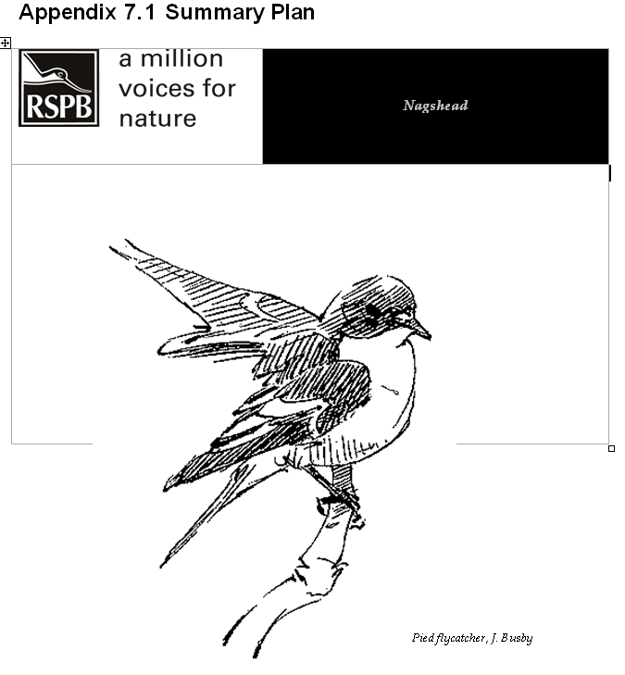

YOUR LOCAL RESERVE
Nagshead is situated in the heart of the Forest of Dean, Gloucestershire. The Forestry Commission own the site and work with the RSPB, through a lease, to manage each habitat in a different way to ensure the continuity of the many different ecological habitats.  The nature reserve covers over 300 hectares of mixed woodland plantation, including nearly 131ha of woodland designated as a SSSI for the Napoleonic oaks which were planted between 1810 and 1848. Much of the rest of the reserve is still managed for a commercial interest with both native broadleaf and exotic conifer species.  Naghead reserve includes the largest extent of old oak woodland within the Forest of Dean. These oaks were originally planted for ship building timber, hence the name Napoleonic oaks, but now share many characteristics with more naturally occurring Western Atlantic Oak Woodland. | This woodland type is important for its special bird assemblage, including pied flycatcher, wood warbler and redstart.  The reserve was established initially to safeguard the important population of pied flycatchers (monitored since 1948) and redstarts. Whilst these are still important species on the reserve there are many other woodland bird species declining nationally, including lesser spotted woodpecker, marsh tit, hawfinch and bullfinch, and Nagshead aims to benefit a range of wildlife through habitat management and research.  The reserve is open to the public throughout the year and has a visitor centre open to the public at weekends through the summer. The reserves experienced team of field teachers lead educational visits for school groups of all ages on the reserve.

Facts and Figures
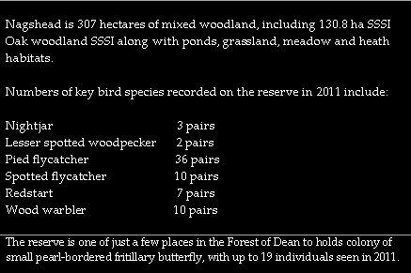

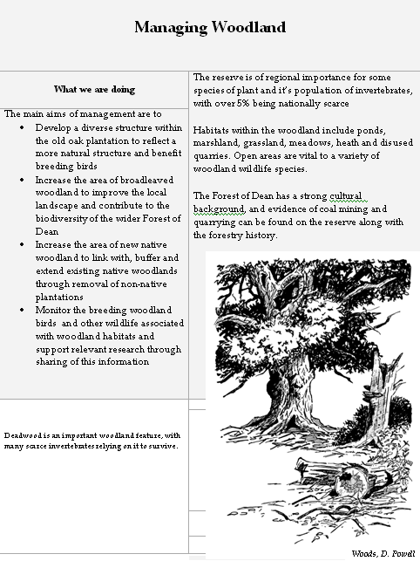

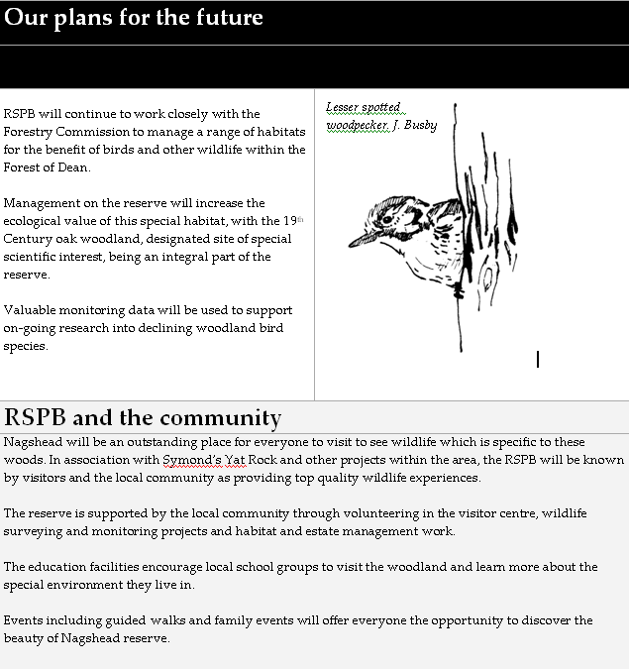

Contact details
Site Manager: Hannah Morton
Assistant Warden: Lewis Thomson

RSPB Gloucestershire Office
The Puffins
Parkend
Lydney
Glos. GL15 4JA

01594 562852
Nagshead@rspb.org.uk
www.rspb.org.uk/nagshead

Regional Office

South West England Office
Keble House
Southernhay Gardens
Exeter
Devon EX1 1NT

