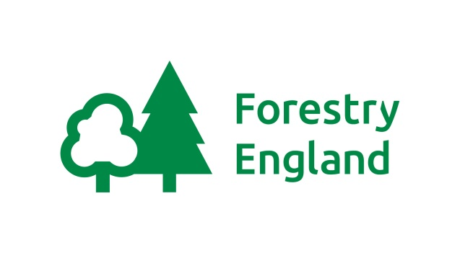
Barbecue terms and conditions 2019

We have 2 fantastic barbecue stands to hire for £68 a day, providing you with your own private space to enjoy the woodland surroundings with friends and family.

Within the woodland glade you’ll find a large barbecue stand capable of catering for approximately 50 people, and 2 picnic benches. You will need to provide the coal, food and friends.
How to Book:
- Choose your day: In spring and summer (May 1st to September 12th) 9.30-7.00pm. In the autumn (4th September to 27th of September) 9.30–6.00pm and then (September 28th to October 24th) 9.30am–5.00pm. Please check gate locking times as they vary throughout the year.
- Call the Information Point on 01296 696184 to find out availability, choose a BBQ and provisionally book (provisional bookings are held for two weeks)
- Print off a booking form and send the office. You can also email the form to: Wendoverbbq@forestryengland.uk. Alternatively, you can call and pay by card over the phone.

You will receive confirmation of your booking along with the combination number to open the barbecue. If you have any difficulties on the day, please contact our duty recreation ranger on 07796 313507 or go to the information point located in our core area.
And now some things to take note of to:
- The group organiser will be responsible for the supervision of the booking.
- Please ensure you take all your litter home with you, including food waste, and leave the site tidy and on time for other groups. Please don’t put your rubbish in the Café bins. Don’t forget to close that padlock. Please note that litter left on-site will be cleared by rangers and the organiser invoiced at a cost of £50.
- Only Charcoal must be used and no other fires lit in the area. Additional stands may be used as long as they are off the ground and no disposables please. Please leave your hot coals behind, do not pour water on the BBQ.
- Parking charges still apply and please ensure you leave the woods before the advertised locking time.
- Unfortunately we do not give refunds for the inclement British weather or other circumstances outside of our control.
- Any cancellations must be made at least one week in advance of the date booked, which will incur a £10 administration charge. No refunds will be made if the cancellation is less than a week before your booked date.
- If you book within 2 weeks of your barbecue date, full payment will be required on booking.
- The Forestry Commission may cancel a booking for health and safety reasons, providing a full refund or alternative date.

www.forestryengland.uk/wendover-woods
www.forestry.gov.uk/wendoverwoods

